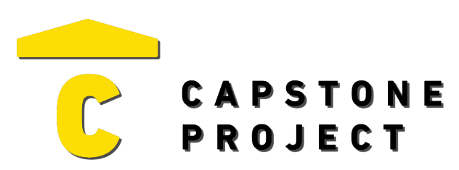
USER FEEDBACK
User Name: Chad Para
What are your thoughts on the project overall?
It is useful to know how to make a enterprise level network

Was the project enjoyable? What was your favorite part of the project?
Watching will suffer doing the analytics
What changes would improve the project?
I do not know

Capstone Project Ratings:
Project Technology Depth (shows good usage of technology) | Medium
Project Breadth (number of features and content) | Low
Professional Presentation (analogous to a real-world product) | High
Implementation Quality (number of bugs and errors) | Medium
Project Completeness (project contains essential functionality) | High

Game / Application / Website Ratings:
Visuals (art style, environment, effects) | Not Applicable
Audio (sound effects, music) | Mixed
UI (title, menus, UI elements, text) | Mixed
Controls (intuitive, ease of use, ease of navigation) | Mixed
Interactivity (fun, engagement, flow) | Mixed

